**Honors College Summer Program in Data Science for the Public Good**

The Virginia Tech Data Science for the Public Good (DSPG) program equips new generations of scientists with the skills they need to inform intelligent governmental policy and decision-making (<https://www.bi.vt.edu/sdal/careers/call-for-students)>. DSPG focuses on the interface of data analytics with critical understanding of social conditions – human habitat and well-being in domains such as healthcare, education, and social justice – to address real problems at the local, state, and federal levels.

DSPG research teams are both vertically-integrated collaboratives of undergraduate and graduate students, post-docs, research staff, and local, state, and federal agency leadership, and horizontally-integrated transdisciplinary efforts that bring together scholars in statistics, data science, and the social and behavioral sciences to address complex issues. Honors students in all academic fields and all grade levels are encouraged to apply for this opportunity.



Honors students in the DSPG summer program work to address the public good by providing outreach to local, state, and federal agencies that brings data science to their programs and agencies. Students work on multiple research projects each summer. In 2016, for instance, projects included --

* helping the Arlington Office of Emergency Management enroll more people in its alerts system by implementing a targeted outreach program;
* helping Arlington County increase its federal transportation funding by developing alternative and better ways to estimate local employment, such as water usage per building;
* helping the Arlington County Fire Department 1) understand the factors affecting its response time to incidents and 2) determine which neighborhoods should be the focus of its outreach efforts to install smoke alarms;
* helping the state of Kentucky analyze progress towards meeting college and career-readiness benchmarks made by each school district and understand trends by race and subject matter;
* helping the National Science Foundation develop new tools to model the dynamics of belief on a massive network scale—resources that could help policymakers predict how the spread of information through digital media will affect public attitudes and health behaviors.

Additional information on Summer 2016 research projects can be found here:

<https://www.bi.vt.edu/sdal/careers/call-for-students/student-poster-presentations>



Participants enroll in consecutive Summer I and Summer II semesters at the Virginia Tech National Capitol Region Campus, earning 6 credits each semester for a total of 12 credits.

Summer I

UH 4504: Honors Discovery and Innovation Studio (3 credits)

UH 4994: Honors Undergraduate Research (3 credits)

Summer II

UH 4504: Honors Discovery and Innovation Studio (3 credits)

UH 4994: Honors Undergraduate Research (3 credits)

Students in the program receive training in topics in data science (including essential tools for scientific and statistical computing such as Hadoop, R, Python, and GIS), problem-based community-based research, research ethics, and policymaking; serve as researchers on multiple projects; work closely with individualized mentors; and interact directly with industry and government agencies through policy events on Capitol Hill and the surrounding area.

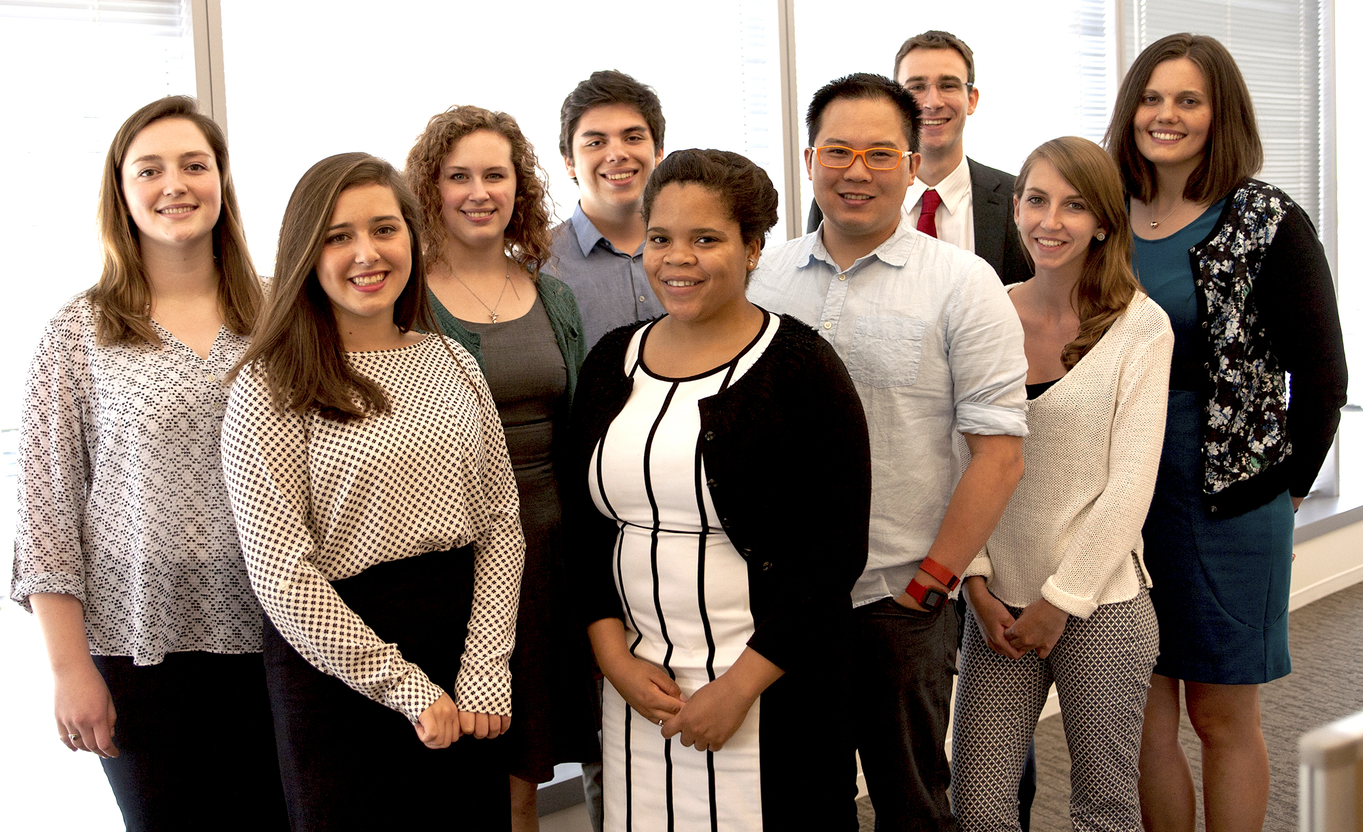

Honors College scholarship funds are available to support students in this program.

Data Science for the Public Good program is delivered by Biocomplexity institute of Virginia Tech. For more information – or to apply for the 2017 program – please contact

Shernita Lee, PhD

Education and Outreach Specialist  
Biocomplexity Institute of Virginia Tech  
1015 Life Science Circle  
Blacksburg, VA 24061

**Phone:**[540-231-7531](tel:(540)%20231-7531)

**Email:** [shernita@vt.edu](mailto:shernita@vt.edu)